The “Voices of Extension History” project aims to increase public awareness of the Cooperative Extension Service, its adult education and 4-H youth development programs during the 2014 Smith-Lever Act’s Centennial Year.

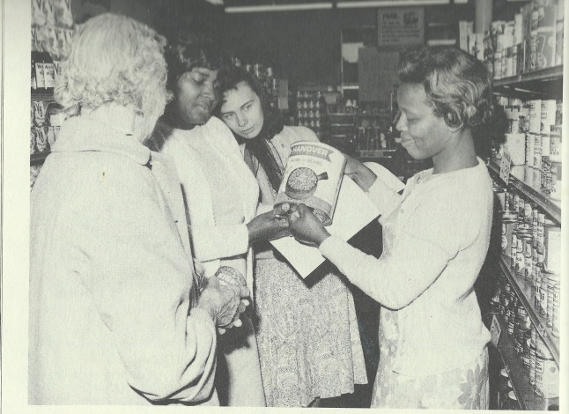
A goal of the “Voices of Extension History” project is to have local 4-H members collect audio/video features which reflect personal and community-based Extension history and illustrate the many programs’ richly significant contributions to the development of America.

Getting different perspectives on history in order to tell the entire story involves asking many different people to share their treasured memories. “Voices of Extension History” will include Agents, beneficiaries and cooperators.

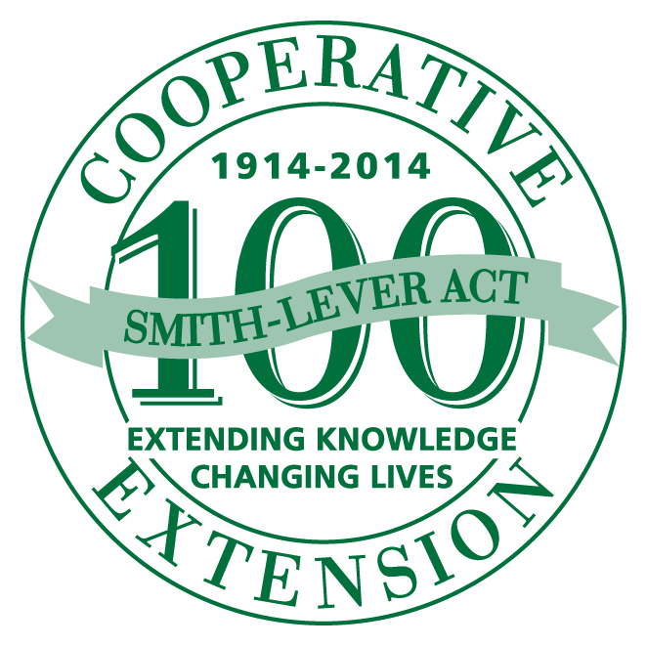

info@4-HHistoryPreservation.com
http://4-HHistoryPreservation.com
The “Voices of Extension History” project aims to increase public awareness of the Cooperative Extension Service, its adult and 4-H youth development programs during the 2014 Smith-Lever Act’s Centennial Year.

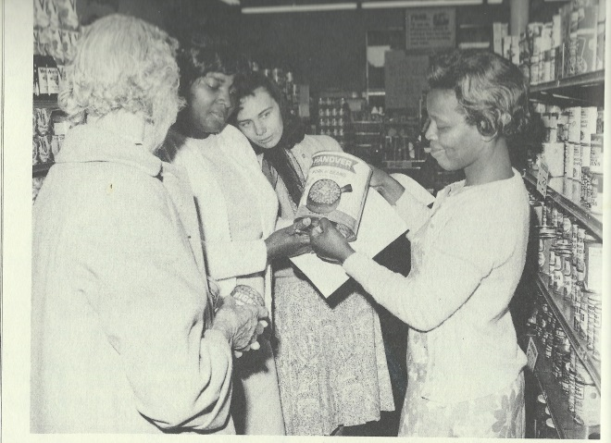
A goal of the “Voices of Extension History” project is to have local 4-H members collect audio/video features which reflect personal and community-based Extension history and illustrate the many programs’ richly significant contributions to the development of America.

Getting different perspectives on history in order to tell the entire story involves asking many different people to share their treasured memories. “Voices of Extension History” will include Agents, beneficiaries and cooperators.

info@4-HHistoryPreservaton.com
http://4-HHistoryPreservation.com
The “Voices of Extension History” project aims to increase public awareness of the Cooperative Extension Service and its adult and 4-H youth development programs during the 2014 Smith-Lever Act’s Centennial Year.

A goal of the “Voices of Extension History” project is to have local 4-H members collect audio/video features which reflect personal and community-based Extension history and illustrate the many programs’ richly significant contributions to the development of America.

Getting different perspectives on history in order to tell the entire story involves asking many different people to share their treasured memories. “Voices of Extension History” will include Agents, beneficiaries and cooperators.

info@4-HHistoryPreservation.com
http://4-HHistoryPreservation.com

