Voices of Cooperative Extension History: the process

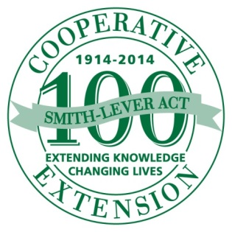  Preparation | Research | Learn the history of Cooperative Extension Service in your community, county, state.
 | Learn | Learn interviewing and story-telling techniques. Study the “Voices of 4-H History” model; visit http://4-HHistoryPreservation.com/Voices/ for a handy “Tool Kit.”
 | Practice | Practice interviewing/vide-taping colleagues, cooperators, donors and beneficiaries so you are comfortable asking questions; learn how to probe for deeper answers.
 | Identify | Who are some people who made your local Cooperative Extension program(s) strong? Consider asking local 4-H members to do the interviews, based on 4-H Voices Project.
 | Define | What is the story these people can tell about local Cooperative Extension history?
 | Brainstorm | What are the questions you’d like to/need to ask to illustrate this story?
Action | Practice | Practice interviewing/video-taping colleagues, cooperators and beneficiaries; ask how your questions will tell the story of the local Cooperative Extension Service History.
 | Equip | Secure the necessary equipment: microphone, recorder, tripod, video camera.
 | Practice | Practice interviewing and video-taping; become comfortable operating audio and video equipment. If local 4-H’ers are doing the interviewing, help them practice as well.
 | Schedule | Explain project to potential interviewees; schedule time to interview and video-tape, maybe several people at one time. Maybe let interviewees see questions in advance.
 | Record | Get Media Releases from interviewees; conduct the interview(s) and taping(s).
 | Edit | Review the audio and video tapes; edit to useable length.
Sharing | Distribute | Go public with the “Voices of Extension History” to radio, TV, fairs, commemorative events; share a copy with your County and University Extension Offices.
 | Share | Let the interviewee(s) hear/see the edited tapes for possible corrections.
 | Thank | Come up with a personal and meaningful way to express your appreciation to the people you interviewed. Maybe the 4-H interviewers could write “Thank You” notes.
 | Combine | Some individual interviews/videotapes might relate to others, so a broader series or story can be told. Re-edit the respective tapes accordingly to create this unique story.
Reflection and  Expansion | Tell us | Share your project with the National 4-H History Preservation Team (info@4-HHistoryPreservation.com); we’d like to know if/how the “Voices of 4-H History” model has worked to help document the “Voices of Cooperative Extension History.”
 | Expand | Based on this year’s success, make plans for future interviews/tapings. This is not the end; this is the beginning. There is a lot more history to record!
 | Document | Interview and videotape yourselves (and/or 4-H interviewers) to create an account of the “Voices of Extension History” project; do this throughout the process. Other communities and counties will be interested in how you accomplished your project; your model will become a training piece for them when they start their own project.
 | Repeat | Involve others in the project; find other staff, participants, beneficiaries, community leaders and cooperators to interview/videotape; expand training to new participants.

http://4-HHistoryPreservation.com

