1Voices Of
Extension
History

The 1914 Smith-Lever Act provided federal funding to the Extension Service in every state. To honor this event, the National 4-H History Preservation Team is leading an Oral History program to capture local success stories of 4-H and Cooperative Extension.

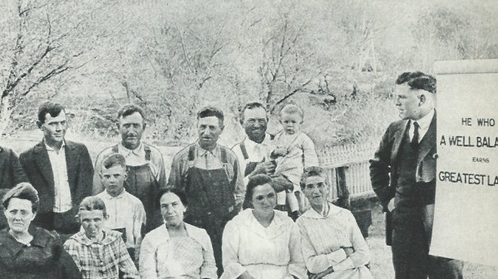

- Celebrates 100 years of the Cooperative Extension Service
- Smith-Lever Centennial 1914-2014
- 4-H youth interviewing current and former Agents, cooperators, beneficiaries and supporters to share their stories
- Audio and/or video recording/editing multi-media
- Share at film festivals and local events
- Preserving Extension’s important history
- Participation is fun for Agents and youth
- Youth gain communication skills
- 4-H’ers showcase Cooperative Extension
- Intergenerational connections
Voices Of
Extension
History

The 1914 Smith-Lever Act provided federal funding to the Extension Service in every state. To honor this event, the National 4-H History Preservation Team is leading an Oral History program to capture local success stories of 4-H and Cooperative Extension.

- Celebrates 100 years of the Cooperative Extension Service
- Smith-Lever Centennial 1914-2014
- 4-H youth interviewing current and former Agents, cooperators, beneficiaries and supporters to share their stories
- Audio and/or video recording/editing multi-media
- Share at film festivals and local events
- Preserving Extension’s important history
- Participation is fun for Agents and youth
- Youth gain communication skills
- 4-H’ers showcase Cooperative Extension
- Intergenerational connections
Voices Of
Extension
History

The 1914 Smith-Lever Act provided federal funding to the Extension Service in every state. To honor this event, the National 4-H History Preservation Team is leading an Oral History program to capture local success stories of 4-H and Cooperative Extension.

- Celebrates 100 years of the Cooperative Extension Service
- Smith-Lever Centennial 1914-2014
- 4-H youth interviewing current and former Agents, cooperators, beneficiaries and supporters to share their stories
- Audio and/or video recording/editing multi-media
- Share at film festivals and local events
- Preserving Extension’s important history
- Participation is fun for Agents and youth
- Youth gain communication skills
- 4-H’ers showcase Cooperative Extension
- Intergenerational connections

